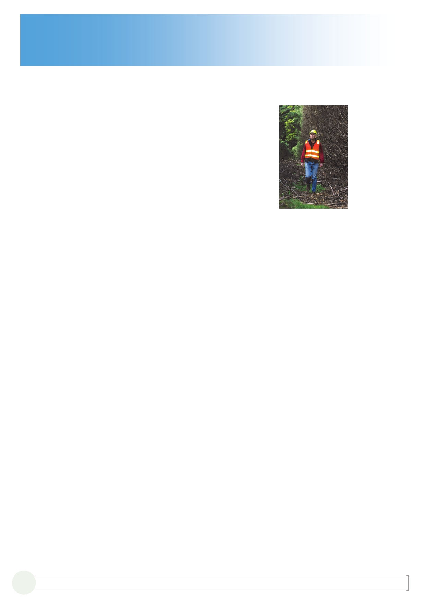
Backen, Paul (from The Forester Dec 2009)

Vale Paul Leslie Backen
8 June 1951 - 14 July 2009

Paul Backen was educated in Canberra and graduated from the Australian National University Forestry School in 1974. He and his wife Gabriel then moved to Tasmania to work for the Forestry Commission of Tasmania - now Forestry Tasmania (FT).
Paul was no exception to the FT rule at the time that all new graduates were to spend their first years on ―assessments (inventory) in as many forest types as possible, in each region of the state, and usually away from home. FT believed that good inventory and assessment skills provided a solid base for a forestry career. The politics of Tasmanian land use were very ―hot‖ in the mid 1970's and Paul's
assessment days took him to some of the most contentious and interesting areas of the south west - the Snake and Denison River assessments, and possibly the last large scale assessment (Precipitous Bluff), where Paul led one of the two 10 men camps.

The inventory hardened and leadership trained Paul Backen was then moved to Geeveston as Assistant District Forester for native forest management experience, and then to Scottsdale as ADFto give him plantation management experience. It was here that Paul found his niche in the management and silviculture of plantations, from land purchase and establishment through roading and harvesting operations.

Smorgon Forests attracted Paul, Gab and the family to Victoria in 1982 as Forest Manager of its Otways and Upper Goulburn
pine plantation estates. He moved to Colac where his office was a dedicated room in the family house - not far to work and never away from work!. He worked on the devastating Ash Wednesday fires of 1983, where a work colleague recounts that the only time he heard Paul swear (shit) was as a huge wall of flames approached.
Paul's passion was the silviculture and management of plantations. The pine clearwood regime was all the go in the early and mid 1980's and Paul had to know every aspect of the process, including climbing to 6 meters on swaying pine trees to prune the limbs!.
Midway Wood Products bought Smorgon Forests in 1995, and Midway commenced the conversion of the pine estate to a proposed exclusive eucalyptus pulpwood estate. Paul's recommendation to maximise planting E. nitens over E. globulus on some high productivity sites has been proven correct after the initial rotation.
Paul was a very calm person, a good negotiator, and was the ideal Midway representative on the multi agency committee that set up the 45-kilometre Old Beechy Rail Trail, part of which passes through Midway lands. Paul was very proud of his role in making suitable arrangements with varying and sometimes competing interests to get the Trail fully operational.
Paul's fieldwork led to the inevitable ―forester bogged vehicle‖ episodes, but contemporaries remember Paul's driving as somewhat unique. Below the calm exterior lurked a rally car driver aspiration without quite the rally car driver skills. Paul managed to get the car stuck on the one and only stump in a paddock, and managed to reverse into the one and only post left in a fence line!. Small trees and scrub were no problem for Paul's (―D4‖) Pajero!. To Smorgon and Midway staff Paul was a consultative leader with a deep knowledge of pine and eucalypt plantation forestry on a wide range of sites and conditions. He was always available to share his extensive experience. His passion for forestry helped his daughter Emily in her career choice, firstly with work experience as a student at Smorgon's, and now as a forester in Tasmania. Paul was a good tennis player, and loved the social aspects of tennis, red wine included. Like most foresters he loved to as we struggled up and down its apparently endless slopes!.
In 2008 Paul was diagnosed with lymphoma, and his calm persona was truly tested by a very cruel illness. He passed away on the 14th of July 2009. Paul is deeply missed by Gabrielle, Emily, Jack, Peter, Alexander and Tom, and their families, and by his many forestry friends.
(Written by Lex Van Saane, with kind collaboration from Steve Roffey and staff at Midway Limited and Peter Gin from Hancock Victorian Plantations.)

